**Environment Variable**

1. **How can you know what is the secondary command prompt set your system ?How can you change the secondary command prompt from the default to your username ?**

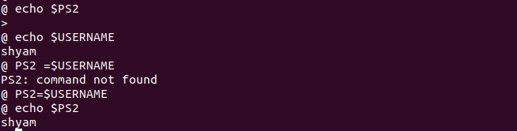

1. **How can you ensure that the mv command (used for renaming a file) always asks for permission before overwriting an existing destination file?**

